Collaborative Work Skills Teacher: Mrs. Roberts, Academic Venture
Category | Did I do it like a 5th grader? |  | Yes | No
Contributions | Routinely provides useful ideas when participating in the group and in classroom discussion. A definite leader who contributes a lot of effort. | 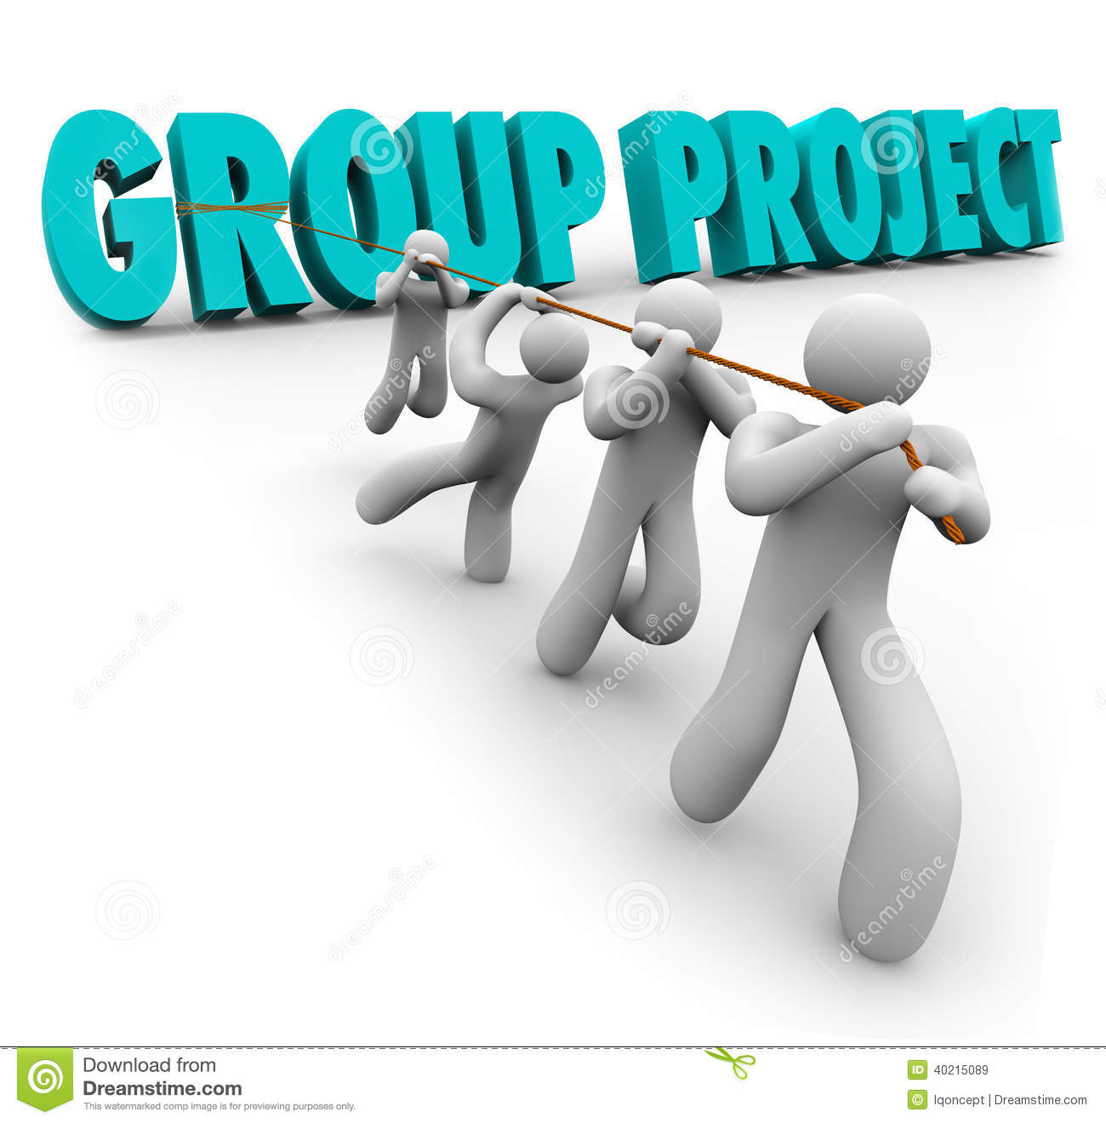
Time-Management | Routinely uses time well throughout the project to ensure things get done on time. Group does not have to adjust deadlines or work responsibilities because of this person's procrastination. | 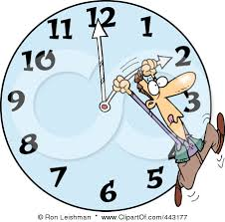
Problem-Solving | Actively looks for and suggests solutions to problems. | 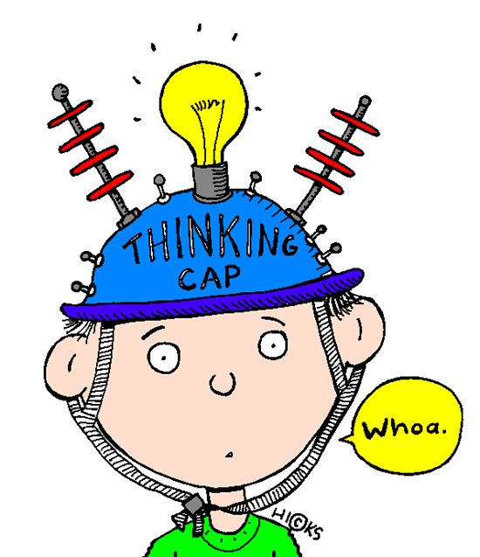
Time Use | Classroom time was used to work on the project. Conversations were not disruptive and focused on the work. | 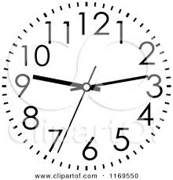
Information Gathering | Accurate information taken from several sources in a systematic manner.
Construction -Materials | Appropriate materials were selected and creatively modified in ways that made them even better. | 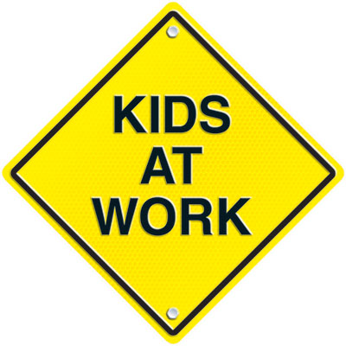
Construction - Care Taken | Great care taken in construction process so that the structure is neat, attractive and follows plans accurately.

Modification/  Testing | Clear evidence of troubleshooting, testing, and refinements based on data or scientific principles. | 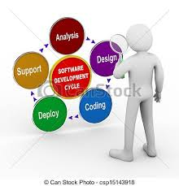
Scientific Knowledge | Explanations by all group members indicate a clear and accurate understanding of scientific principles underlying the construction and modifications.
Error Analysis | Experimental errors, their possible effects, and ways to reduce errors are discussed.
Materials | All materials and setup used in the experiment are clearly and accurately described.
Summary | Summary describes the skills learned, the information learned and some future applications to real life situations.

